The comments are just for your instruction.

Kindly DELETE the comments and this entire page before saving this file to upload. You could see in the bellow picture to know how to delete all of the comments from the ‘Review’ toolbar:
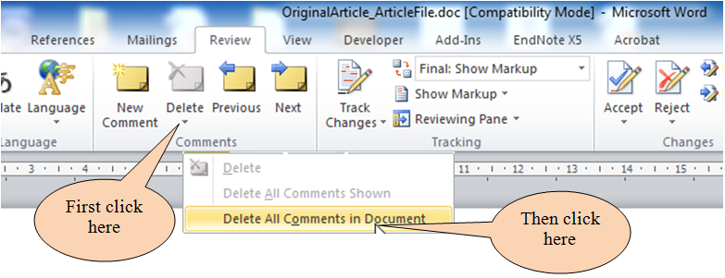
Please save your file as a ‘Word 97-2003 document’ before uploading it to the submission web page. [File Save As Word 97-2003 document (*.doc)]
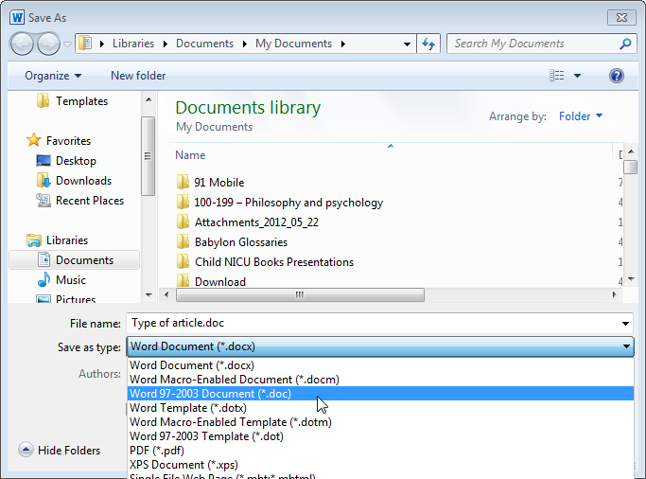
(1) Please choose this option as your file type.
(2) Please check to be sure that “.doc” extension appears here.
Covering letter
Covering Letter
To,
The Editor

Sub: Submission of Manuscript for publication
Dear Sir,
We intend to publish an article entitled “ ” in your esteemed journal as a Case Report.
On behalf of all the contributors I will act and guarantor and will correspond with the journal from this point onward.
Prior publication
Support
Conflicts of interest
Permissions
We hereby transfer, assign, or otherwise convey all copyright ownership, including any and all rights incidental thereto, exclusively to the journal, in the event that such work is published by the journal.
We would like to suggest following referees for the article:

Yours’ sincerely,

Signature

Corresponding contributor:

E-mail -
Encl : Three copies of the manuscript
Three copies of the photograph

Type of article: Case Report
Title Page

Title of the article:

Running title :
Contributors
1.

ORCID ID:
2.
3.
4.

Department(s) and institution(s)

Corresponding Author:

ORCID ID:

Total number of pages:

Total number of photographs:

Word counts
For abstract:
For the text:

Financial support and sponsorship

Presentation at a meeting:
Organisation
Place
Date

Conflicting Interest (If present, give more details):

Acknowledgement:

Contribution Details (to be ticked marked as applicable):

 |  | Contributor 1 | Contributor 2 | Contributor 3 | Contributor 4
Conception and  design, or acquisition of data, or analysis and interpretation of data | Concepts
 | Design
 | Definition of intellectual content
 | Literature search
 | Clinical studies
 | Experimental studies
 | Data acquisition
 | Data analysis
 | Statistical analysis
Drafting the article or revising it critically for important intellectual content | Manuscript preparation
 | Manuscript editing
Final approval of the version to be published | Manuscript review
 | Guarantor

Do NOT forget to delete the COMMENTS, the INSTRUCTION PICTURES and THIS SENTENCE before uploading your file.

Checklist (to be tick marked, as applicable)

Manuscript Title __________________________________________________________________________________
Checklist

Covering letter
- Signed by all contributors
- Previous publication / presentations mentioned
- Source of funding mentioned
- Conflicts of interest disclosed

Authors
- Middle name initials provided
- Author for correspondence, with e-mail address provided
- Number of contributors restricted as per the instructions
- Identity not revealed in paper except title page (e.g. name of the institute in material and methods, citing previous study as ‘our study’, names on figure labels, name of institute in photographs, etc.)

Presentation and format
- Double spacing
- Margins 2.5 cm from all four sides
- Title page contains all the desired information (vide supra)
- Running title provided (not more than 50 characters)
- Abstract page contains the full title of the manuscript
- Abstract provided (not more than 150 words for case reports and 250 words for original articles)
- Structured abstract provided for an original article
- Key words provided (three or more)
- Key messages provided
- Introduction of 75-100 words
- Headings in title case (not ALL CAPITALS, not underlined)
- References cited in superscript in the text without brackets
- References according to the journal’s instructions.

Language and grammar
- Uniformly British English
- Abbreviations spelt out in full for the first time
- Numerals from 1 to 10 spelt out
- Numerals at the beginning of the sentence spelt out

Tables and figures
- No repetition of data in tables/graphs and in text
- Actual numbers from which graphs drawn, provided
- Figures necessary and of good quality (colour)
- Table and figure numbers in Arabic letters (not Roman)
- Labels pasted on back of the photographs (no names written)
- Figure legends provided (not more than 40 words)
- Patients’ privacy maintained (if not, written permission enclosed)
- Credit note for borrowed figures/tables provided

